# Requirements Specification for Forest

Author: Zhang Peiya, Fang Haonan, Pan Xinwei, Yan Yangtian, Zhang Lei

Date: April 2021

## Introduction

### Purpose

This document describes selected requirements of the English version of the app “WeChat”. The document is based on the IEEE 830 recommended practice for requirements specification. It is intended to illustrate how requirements for an app may be documented.

For questions and suggestions, please approach [samuel.fricker@bth.se](mailto:samuel.fricker@bth.se).

### Scope

The document specifies the Chinese Android variant of Forest version 4.34.2 as installed on a Samsung Galaxy S9 Plus.

In detail are specified the following features:

-Existing feature being specified: Focus Countdown. Set and start a focus time countdown, users are not allowed to open other mobile phone software during this time, otherwise the tree will wither. This is the key feature of Forest.

-New feature being specified: Time to Sleep. Alert users that the time they set for sleeping has arrived, prohibit users from turning on their phones during the sleep time. This is a newly invented feature.

The remaining features are just outlined.

### Definitions, Acronyms, and Abbreviations

The following table lists terms (acronyms and abbreviations), gives their definitions, and documents the source for the definition.

|  |  |  |
| --- | --- | --- |
| Term | Definition | Source |
| End-User | A person that is interacting with the app through the graphical user interface. |  |
| … |  |  |

### References

* IEEE 830 Recommended Practice for Software Requirements Specification: <http://www.math.uaa.alaska.edu/~afkjm/cs401/IEEE830.pdf>. This document was used to define the table of contents.
* WeChat App Description on Google Play: <https://play.google.com/store/apps/details?id=com.tencent.mm>. This page was used to identify the features of WeChat v6.5.7 and to download a running instance of the app.
* Pohl, K., Rupp, C. (2015): Requirements Engineering Fundamentals. Rocky Nook. This book was used for selecting requirements specification practices.

### Overview

The remainder of this document is structured as follows. Chapter 2 gives an overview of the specified app. Section 3 specifies the detailed requirements.

## Overall Description

### Vision

2.1.1 Problem statement

The problem of using the phone before bed and involuntarily start to stay up late affects students and office workers with the impact of insufficient sleep time, poor sleep quality and even sleep disorders. A successful solution would help to overcome the addiction of playing mobile phones before sleeping.

2.1.2 Solution concept

For students and office workers who stay up late at night playing with their phones, the Forest use running software detection for prohibiting users from opening other software during the sleep time set by themselves. Users are rewarded for not using their phones within the set time, otherwise, trees planted in Forest by users will wither.

2.1.3 Differentiating innovation

Unlike traditional application simply tells users it's time to sleep, by proscribing the access to other apps, the product allows to develop good sleep habits and improve sleep quality for users. Furthermore, it can help users feel better the next day and get rid of the lethargy caused by lack of sleep time.

### Storyboard

### 2.2.1 Existing Feature: Focus Countdown

The storyboard in Figure 1 shows the use of the feature. The individual want to study but he lack of self-control(1st drawing). So he want to find a app to keep himself focus on work. So he can set a countdown clock, in the limited time, he can't use his phone so that he can focus on what he should do(2nd drawing). After he finishing his work, he will get a new tree and some coins in Forest for award(3rd drawing).

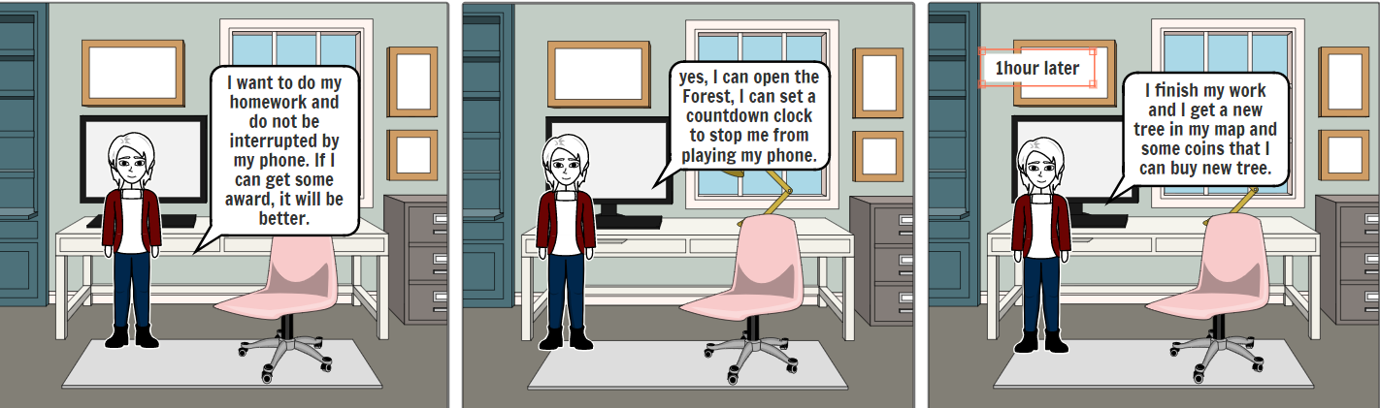

Figure 1: Storyboard for Focus Countdown.

### 2.2.2 New feature: Time to Sleep

The storyboard in Figure 2 shows the use of the feature. The individual can't control himself playing phone at night.  He will feel tired in tomrrow morning at school(1st drawing). So he can set a sleep clock and set the award(2nd drawing). At bedtime, if he want to play his phone(3rd drawing), the Forest will Stop him from using his cell phone(4th drawing). So the only thing he can do is sleep(5th drawing). And tomorrow morning, he will get a new tree in his map as award.

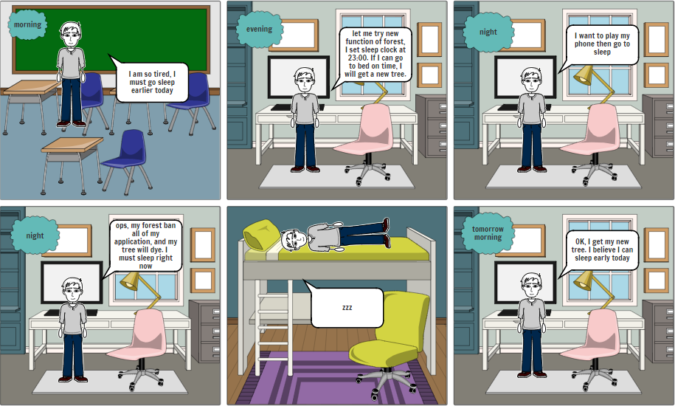

*Figure 2: Storyboard for Time to Sleep.*

### Viewpoints

The diagram in Figure 3 shows the Android Forest Client and its context, consisting of the humans and external systems that the Forest client interacts with. The context is considered as the source of the requirements for the Forest Client. The tables in sections 2.3.1-2.3.3 specify the context and the needs implied by that context in more detail.

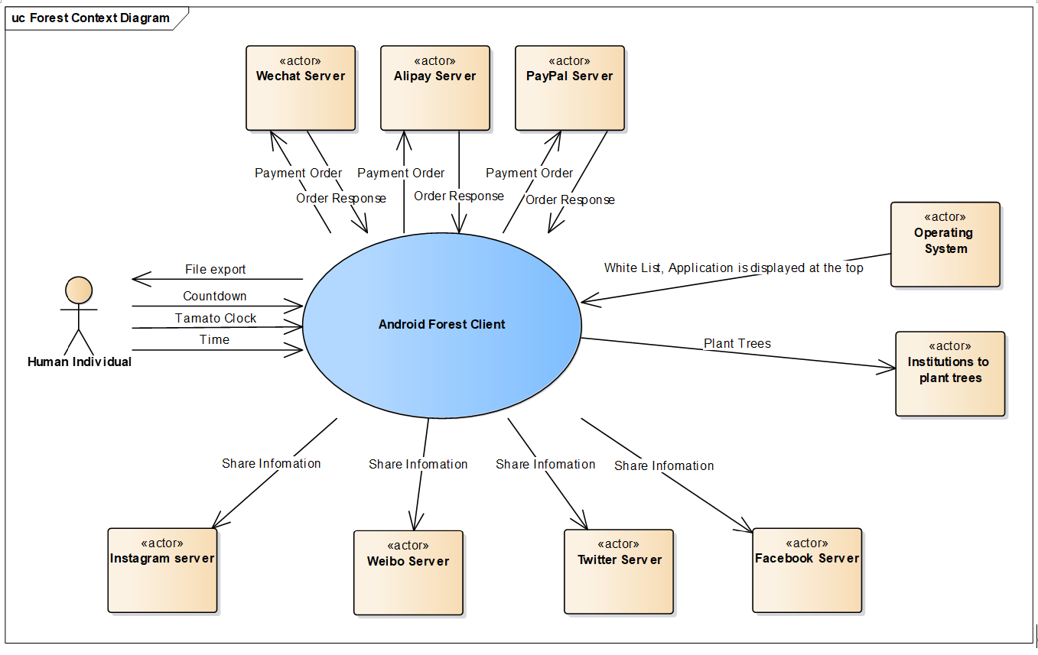

*Figure 3: System Context Diagram (based on UML Use Case Diagram Notation).*

### 2.3.1 Users

|  |  |  |
| --- | --- | --- |
| User | Background | Needs |
| Human Individual | According to the Forest vision, we can suppose that each user has a smartphone and they have capabilities to use the Forest by reading the prompt. | Sleep on time, stop spending plenty of time in playing with various of apps. Develop a good sleeping habit and get rid of lack of energy. |

### 2.3.2 External Systems

|  |  |  |
| --- | --- | --- |
| External System | Description | Needs |
| Operating System | The program runs on the operating system, and part of its functionality is based on acquired permissions | The application can obtain permission that applications are displayed at the top and permission that retrieves the running application with the user's permission. API for permission:  <https://developer.android.com/guide/topics/permissions/overview> |
| WeChat Server | The WeChat server running the WeChat back-end. | A user sends a payment order to WeChat payment and returns a confirmation message after the payment is completed. API for WeChat:  <https://pay.weixin.qq.com/wiki/doc/apiv3/open/pay/chapter2_5_0.shtml> |
| Alipay Server | The Alipay server running the Alipay back-end. | A user sends a payment order to Alipay and returns a confirmation message after the payment is completed.  API for Alipay: <https://opendocs.alipay.com/apis/api_1/alipay.trade.app.pay> |
| PayPal Server | The PayPal server running the PayPal back-end. | A user sends a payment order to PayPal and returns a confirmation message after the payment is completed. API for PayPal: <https://developer.paypal.com/docs/api/payments/v2/> |
| Weibo Server | The Weibo server running the Weibo back-end. | A user shares information about the application and send it to third-party social software. API for Weibo:  <https://open.weibo.com/wiki/> |
| Twitter Server | The Twitter server running the Twitter back-end. | A user shares information about the application and send it to third-party social software. API for Twitter:  <https://dev.twitter.com/rest/public> |
| Facebook Server | The Facebook server running the Facebook back-end. | A user shares information about the application and send it to third-party social software.  API for Facebook:  <https://developers.facebook.com/> |
| Instagram Server | The Instagram server running the Instagram back-end. | A user shares information about the application and send it to third-party social software. API for Facebook: <https://developers.facebook.com/docs/instagram/sharing-to-feed> |
| Institutions to plant trees | The real tree planting service is carried out by the tree planting agency | A user meets the requirements and applies for tree planting within the program, and the application communicates with the tree planting organization. URL of institutions: https://trees.org/sponsor/forest-app/ |

2.3.3 Other Viewpoints

|  |  |  |
| --- | --- | --- |
| Other stakeholders | Description | Needs |
| Government | The government is committed to protecting people's privacy, so personal data leakage will not be tolerated. | The personal information and sleep time record in the Forest shall be stored in a safe database, only authorized people can access the database. These data must be deleted after 3 months. |

### Features

### 2.4.1 Existing Feature: Focus Countdown

The Focus Countdown function prompts us to put down the mobile phone within a set period of time, shield the interference from the mobile phone, concentrate on the current study/work, and establish an efficient and focused lifestyle.

The feature is implemented by using running software detection. Users define the tree species, time and label of the focus countdown. Click the "Start" button to enter the focus state, then the countdown time will appear on the screen. If users open another app during this time, they will receive a warning from Forest. Users will get a gold reward after a successful focus countdown, otherwise the tree which users’ plant will wither.

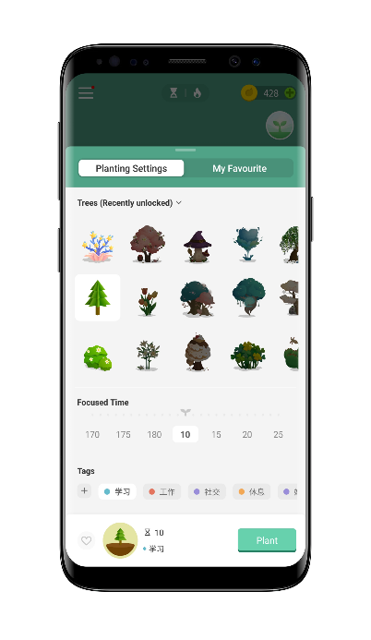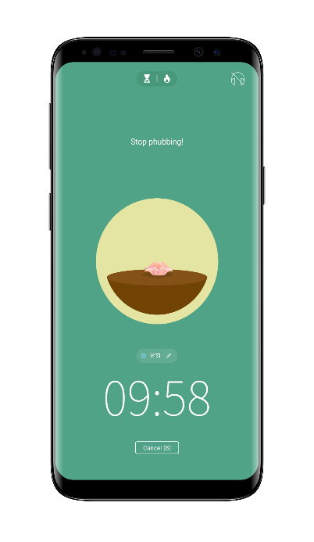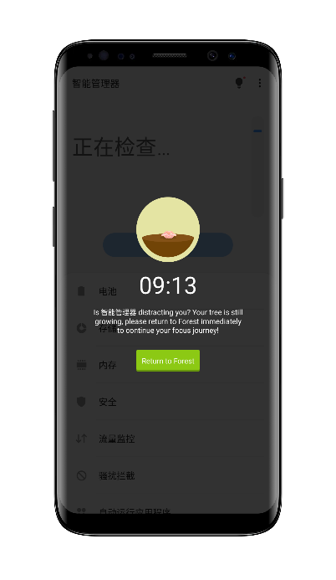

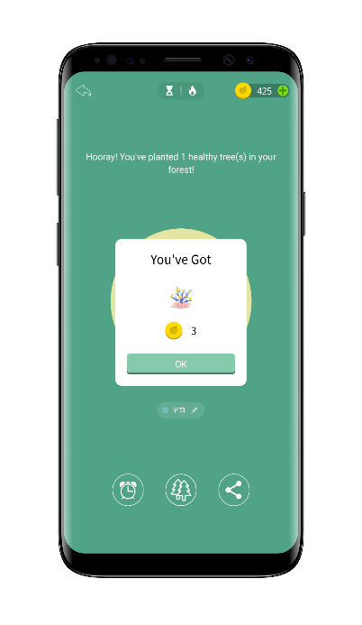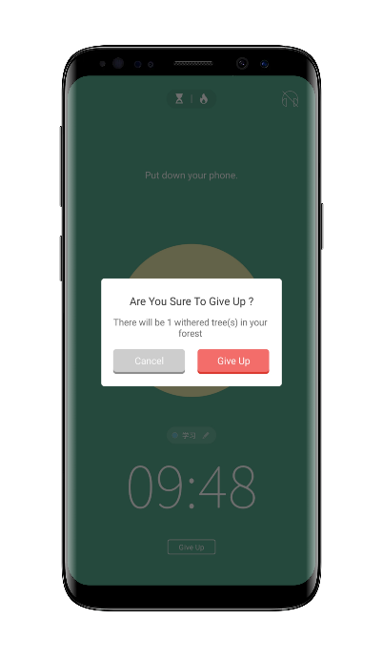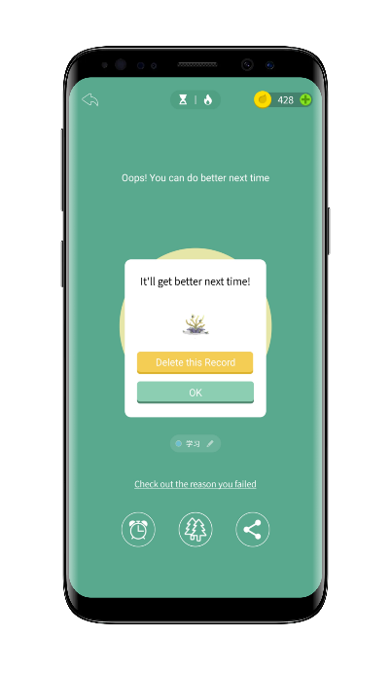

*Figure 4:  Illustration of the Forest Countdown User Interface.*

### 2.4.2 New Feature: Time to Sleep

The feature time to sleep provides the user varieties of approach to get rid of cell phone. With the help of some sleeping module, our user can set their sleep time period and relax their minds, so that fall asleep faster and have awesome sleep quality to improve their daytime work quality.

·At the top center of main page (Figure 5) of sleep function, like the focus function we similarly place a tree with the sleep time schedule. Click the tree you can pop up the frame to choose the species of the tree or set the time. Under the tree lies two scroller can set the start and the end time of the sleep as well. below them is the module of function cards. There are cards with hints of streamlined features that can also be linked to corresponding detail pages.

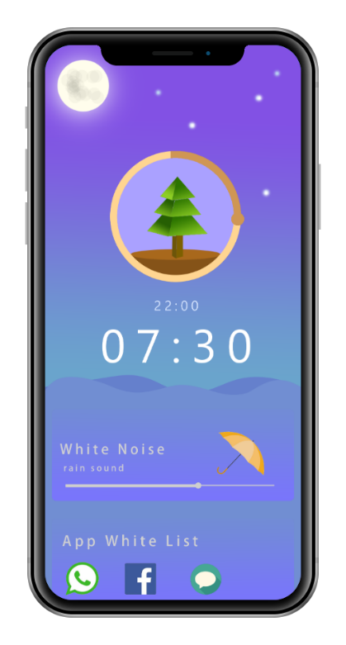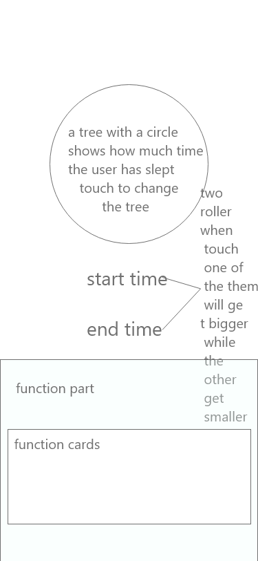

*Figure 5: User Main Interface of the Forest Time to Sleep*

·On click the tree there will pop up a frame with tree icons let the user to choose the tree and set the sleep time. (Figure 6)

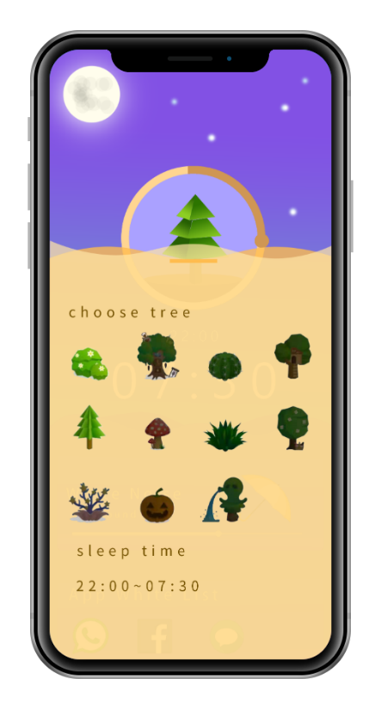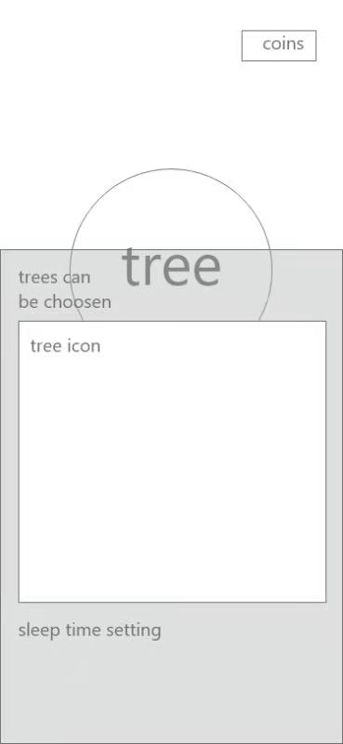

*Figure 6: User Interface of Choosing the Saplings to Plant*

·Scroll up the main page there are cards with hints of streamlined features that can also be linked to corresponding detail pages in Figure 7. user can do some basic operations like change the white noise, control the voice level, add some new apps into the white list.

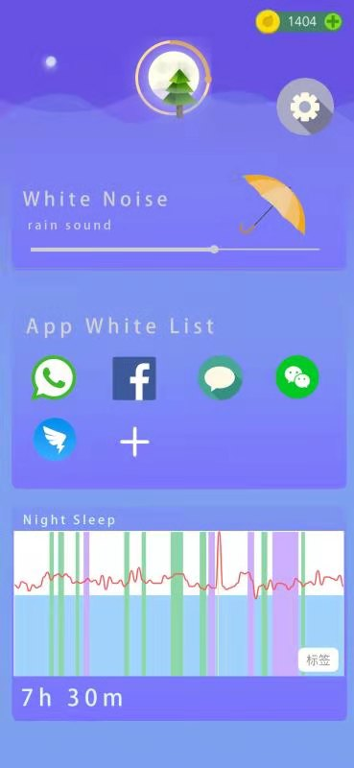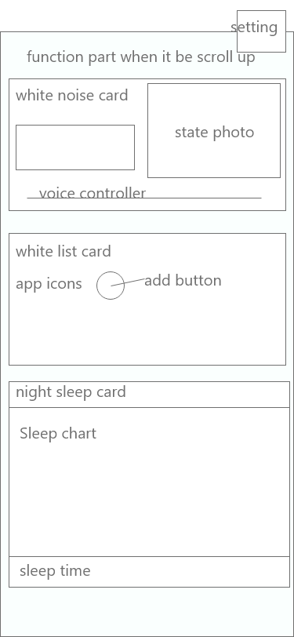

*Figure 7: The Control Interface*

·In the function cards group the app shall provide users a approach to customize the sequence of cards and which cards shall be shown. (*Figure 8*)

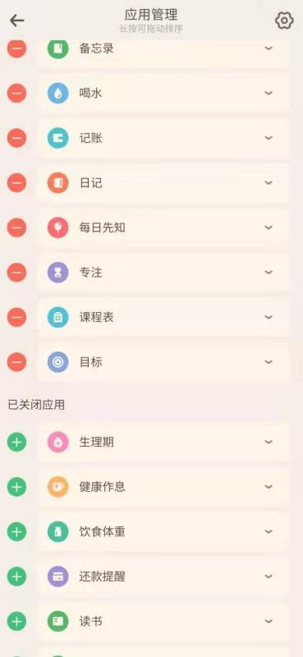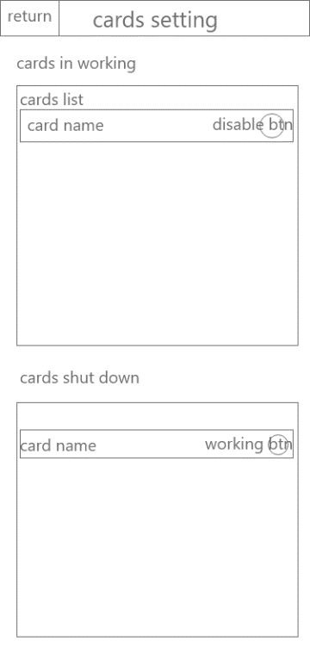

*Figure 8：Card Setting Page*

·With the app list provided by the system we can add some apps into the white list in order to use when it needed. (*Figure 9*)

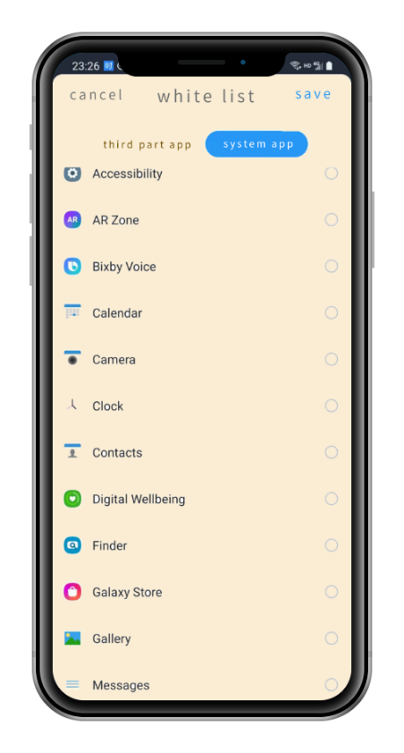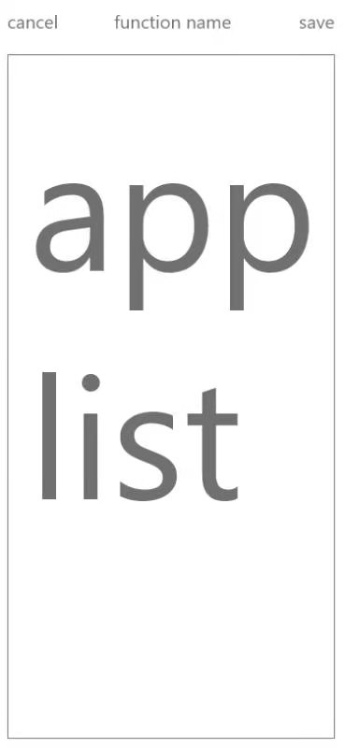

*Figure 9: Whitelist Application Modification Page*

·In app white list we can warn the user when he/she want to add some of the apps may distarct him/her. (*Figure 10*)

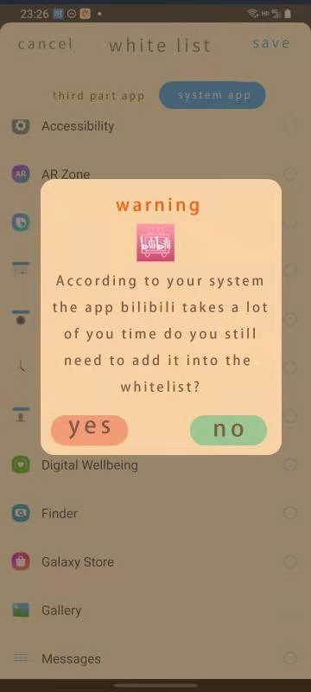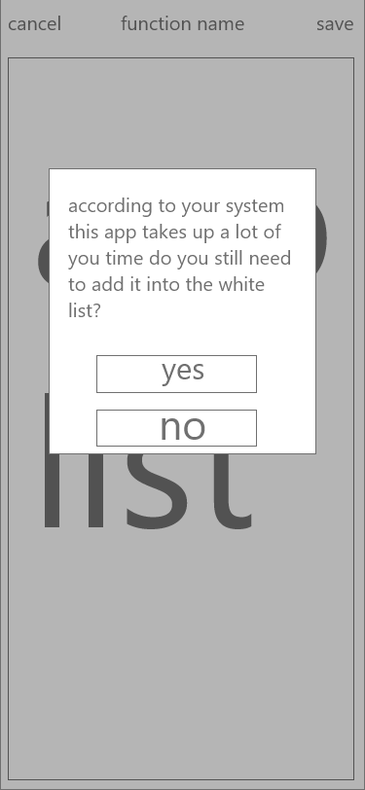

*Figure 10：Adding Application in the Whitelist*

·In the sleep analyze page according to the data provided by user's wearable devices we can provide a sleep analyze chart with some basic data. (Figure 11)

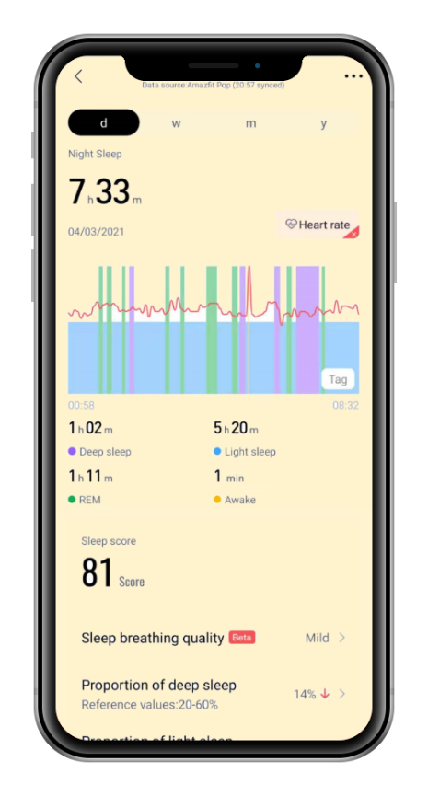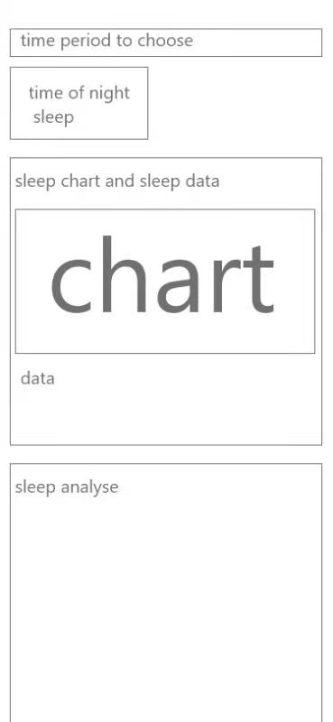

*Figure 11: Sleep Quality Results Report*

·In the detail page of white noise, the app will provide some photos according to the theme of the white noise in playing. And the user can control the voice level by slider and switch the theme by switch tabs. (Figure 12)

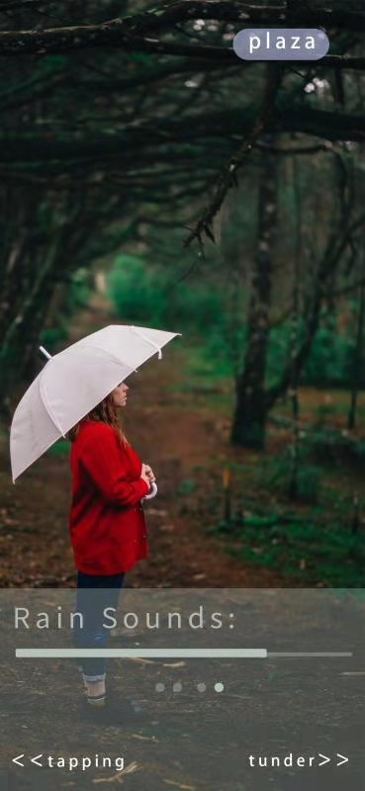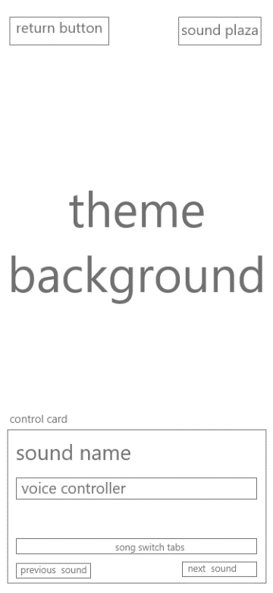

*Figure 12: Detail Page of White Noise*

·White noise page shall give more details about the sounds can be choose, beside the sound in playing and white noise page can give users more choices, these choices can be unlocked by using coins (Figure 13)

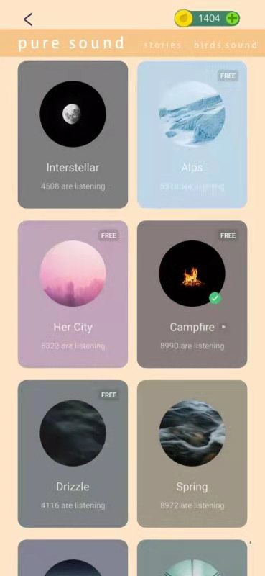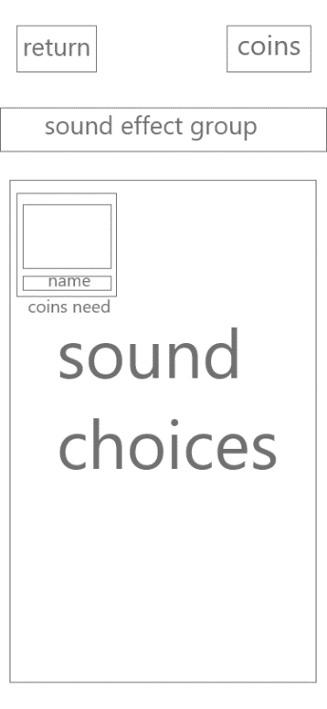

*Figure 13：Nosie page*

·When users use apps that don't belong to the white list during the sleeping time set by themselves, the forest app will pop up and warn the user to choose. (Figure 14)

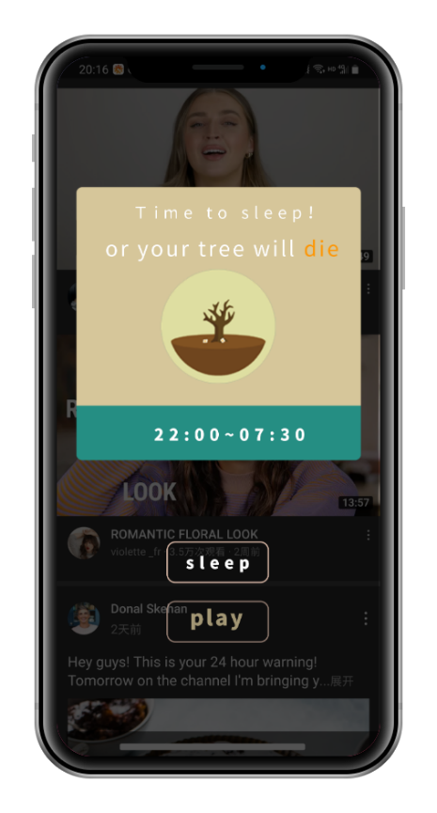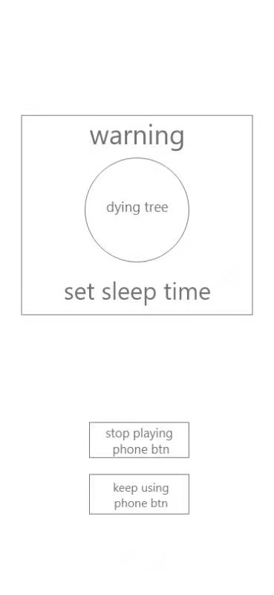

*Figure 14: Warning for Using Non-specified Applications*

### Constraints

|  |  |  |
| --- | --- | --- |
| ID | Title | Constraint |
| C001 | Programming language | The Java language is highly portable, object-oriented and easy to program, and supports multi-thread. |
| C002 | Database | MySQL is an open source database with an interface that supports multiple language connection operations, and it  has a very flexible and secure permission and password system. MySQL also has a very fast and stable thread-based memory allocation system that can be used continuously without worrying about its stability. |
| C003 | API | The exact interface specified by each service must be invoked, such as Alipay Server, PayPal Server. |

## Specific Requirements

### Feature 1…

### Feature 2…

### Data Perspective